AI FITTRACK API
PROJECT DOCUMENTATION

SUBMITTED BY:
Team ID : SWTID-2026-9467
Team Size : 5
Team Leader : JANANI M Team member : KARTHIKA B Team member : SASMITHA S Team member : SWETHA V Team member : RAMYA S

Abstract
Node.js • Express.js • MongoDB • REST API • AI Service • Thunder Client

AI FitTrack API is a backend application designed to provide fitnessrelated services through secure RESTful APIs. The system combines user authentication, workout information, fitness insights and AI-assisted workout recommendations in a single application. The backend is implemented with Node.js and Express, while MongoDB is used for persistent data storage. AI-generated responses are integrated through a dedicated service layer. The project is tested using Thunder Client, where successful API responses, authentication tokens and fitness outputs are verified. The objective is to provide a modular and extensible foundation for a personalized fitness application.

AI FitTrack API | 2/18

Introduction
AI FitTrack API is developed as a server-side application that allows a fitness platform to communicate with users, workout data and AI services through well-defined API endpoints. It follows a REST-based architecture in which clients send HTTP requests and receive structured JSON responses. Authentication is handled using token-based security, while workout and fitness functions are separated into controllers, routes, models and services. This separation makes the application easier to maintain, test and extend. The project demonstrates how a modern backend can connect database operations with AI-powered fitness functionality.

Existing System
Traditional fitness applications often depend on fixed workout plans, manual progress tracking and separate services for authentication and recommendations. In such systems, users may receive generic suggestions that do not adapt to their workout history or stated goals. Data can also become difficult to manage when authentication, workout records and recommendation logic are implemented without a clear modular structure. These limitations create a need for a backend that can securely manage user information while also supporting dynamic fitness analysis and AI-assisted recommendations.

Proposed System
The proposed AI FitTrack API provides a centralized backend for authentication, workout management, fitness insights and AI recommendations. Users can register and log in, receive a secure token, access their profile and submit fitness information for analysis. The AI service processes relevant inputs and returns a personalized recommendation or insight in JSON format. The application is organized into routes, controllers, middleware, models and services, allowing each responsibility to be developed independently. MongoDB stores application data and Express handles API communication.

Objectives
The main objective of the project is to develop a reliable REST API for a fitness application with AI-supported functionality. The system aims to provide secure user registration and login, protect authenticated endpoints using bearer tokens, store fitness-related information in a database, generate workout recommendations from user inputs, and produce fitness insights from workout statistics. Another objective is to demonstrate a clean backend architecture that can be integrated with a web or mobile front end in the future.

System Requirements
The software requirements include a modern operating system, Node.js runtime, npm package manager, Express.js framework, MongoDB database and an API testing client such as Thunder Client or Postman.
The application also requires an environment configuration file for database and AI service settings. Development can be performed in Visual Studio Code or another JavaScript-compatible IDE. A stable internet connection may be required when the application communicates with an external AI service. The system is designed to run locally in development mode on a configured server port.

System Design
The system follows a layered backend design. Client requests first reach Express routes, which identify the requested API endpoint. Controllers handle request processing and coordinate with models or services. Authentication middleware verifies bearer tokens before protected resources are accessed.
Models represent application data stored in MongoDB, while the AI service communicates with the configured AI provider and returns generated fitness content. This structure separates responsibilitieS and improves maintainability, testing and future integration.

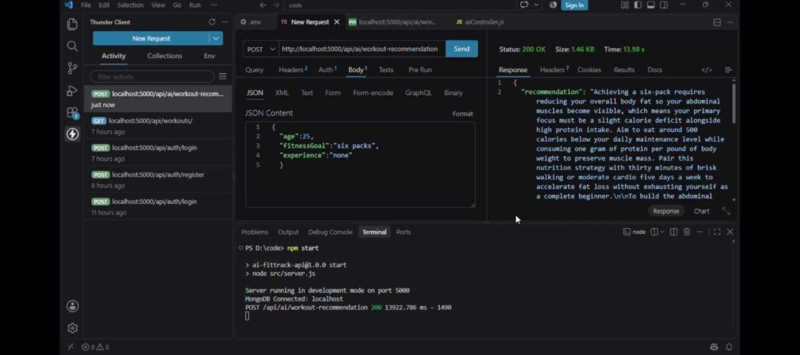

API Design & Implementation
The API is implemented using REST conventions with HTTP methods such as POST and GET. Authentication endpoints support user registration and login, while a protected profile endpoint verifies the bearer token before returning user information. AI endpoints accept JSON fitness data and

return structured recommendation or insight responses. Express routes connect URLs to controllers, and the service layer handles AI-specific processing. Successful requests return HTTP status codes such as 200 OK or 201 Created, making the API behavior easy to test and integrate.
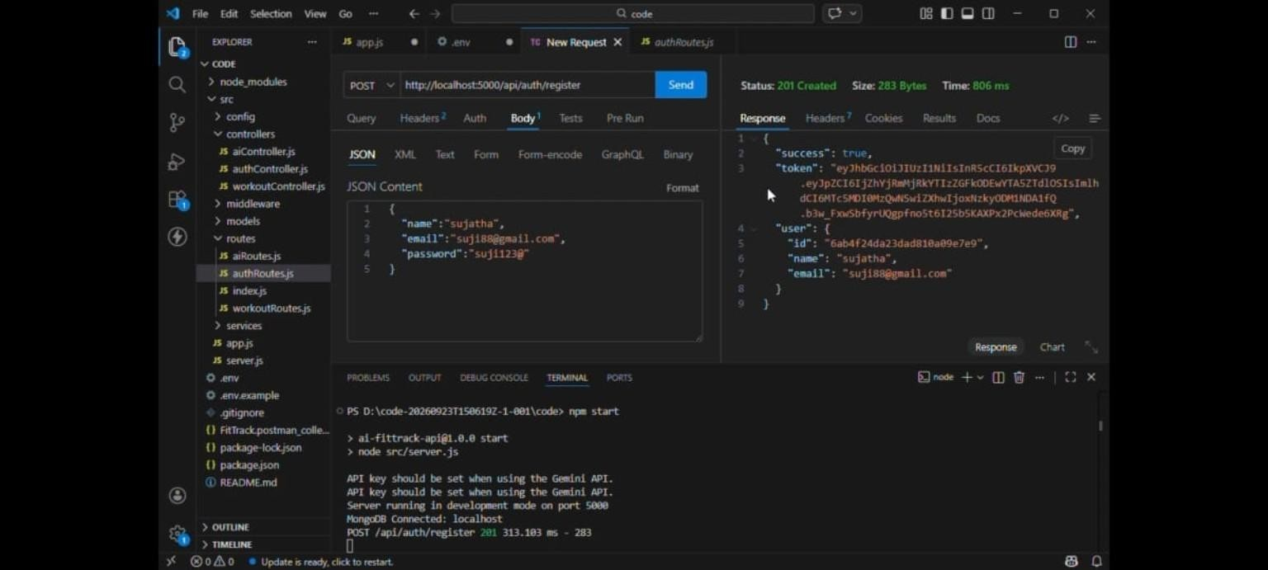

Modules
The project is divided into functional modules to keep the implementation organized. The Authentication module manages registration, login, token generation and profile access. The Workout module manages workoutrelated operations and data. The AI module receives fitness information and produces recommendations or insights through the AI service.
Middleware provides authentication and request protection. The Database module connects the application with MongoDB and supports persistent storage through models. Routes act as the entry points that connect client requests to the corresponding controllers.

Database Design
MongoDB is used as the database because its document-oriented structure is suitable for storing user and workout information in JSON-like documents. User records can contain an identifier, name, email and securely handled authentication information. Workout-related records can contain details such as workout duration, calories and other fitness statistics. The application connects to MongoDB through the backend configuration, and the terminal output confirms a successful local database connection. The database design can be extended with additional collections for goals, progress history and personalized recommendations.

Testing
API testing is performed using Thunder Client inside Visual Studio Code. The registration endpoint is tested with a JSON request and returns HTTP 201 Created when a user is successfully registered. The login endpoint returns HTTP 200 OK and provides an authentication token. The profile endpoint is then tested with a bearer token and returns the authenticated user's information. AI endpoints are also tested with fitness-related JSON input to verify that the server returns recommendation and insight responses.

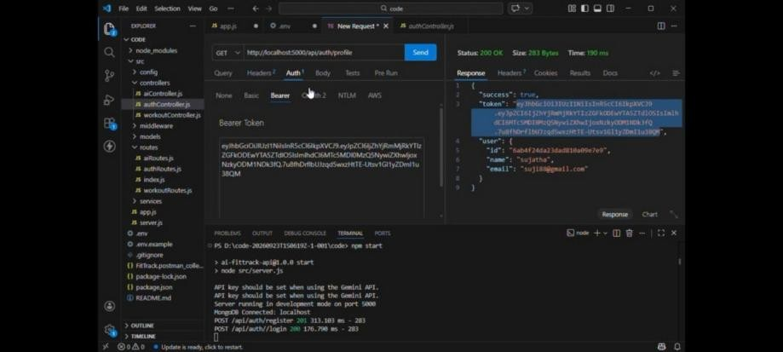
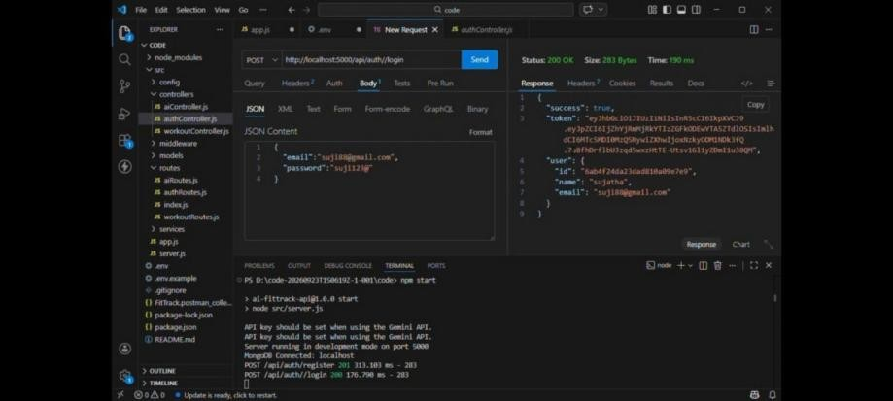

Results & Discussion
The testing results show that the major API operations respond successfully in the development environment. Registration and login requests are processed by the authentication routes, and the generated bearer token is accepted by the protected profile endpoint. The fitness-insights endpoint returns a structured AI-generated insight from the supplied workout statistics. The workout-recommendation endpoint also returns an AI-generated recommendation based on the provided fitness goal and experience. These results demonstrate the integration of routing, authentication, database connectivity and AI services.
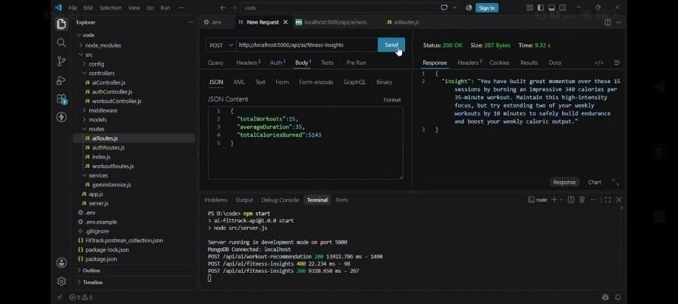
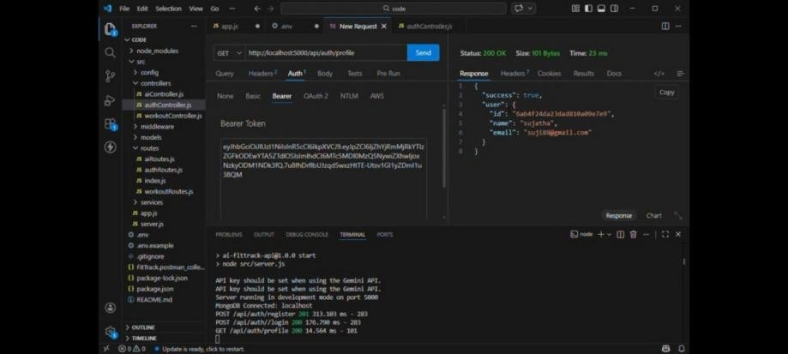

DEMO VIDEO LINK
https://drive.google.com/file/d/1bPEBxLkzjUv9WPXmPWhz0P94H7yY3n2-
/view?usp=drivesdk

Advantages
AI FitTrack API provides a modular and reusable backend structure that can support different client applications. Token-based authentication helps protect user-specific resources, while MongoDB provides flexible storage for fitness information. The AI integration allows the application to generate dynamic recommendations and insights instead of relying

only on fixed text. RESTful endpoints make the system straightforward to test and integrate. The separation of routes, controllers, middleware, models and services also makes future maintenance and feature expansion easier.

Limitations
The current implementation depends on correct configuration of the database and AI service credentials. AI-generated recommendations may vary because they are produced dynamically and should be treated as application guidance rather than professional medical or fitness advice.
The backend shown in the project is primarily a development-stage API and does not by itself provide a complete user interface. Additional

production features such as stronger validation, rate limiting, monitoring, deployment security, comprehensive automated tests and more detailed workout-history management can be added in future versions.

API Workflow & Integration
The overall request flow begins when a client sends an HTTP request to an Express route. The route forwards the request to the appropriate controller, where input is validated and the required operation is selected. Protected endpoints first pass through authentication middleware, which verifies the bearer token. The controller then communicates with MongoDB models or the AI service as required.
Finally, the server returns a JSON response with an appropriate HTTP status code. This workflow keeps authentication, business logic, data access and AI processing separated.

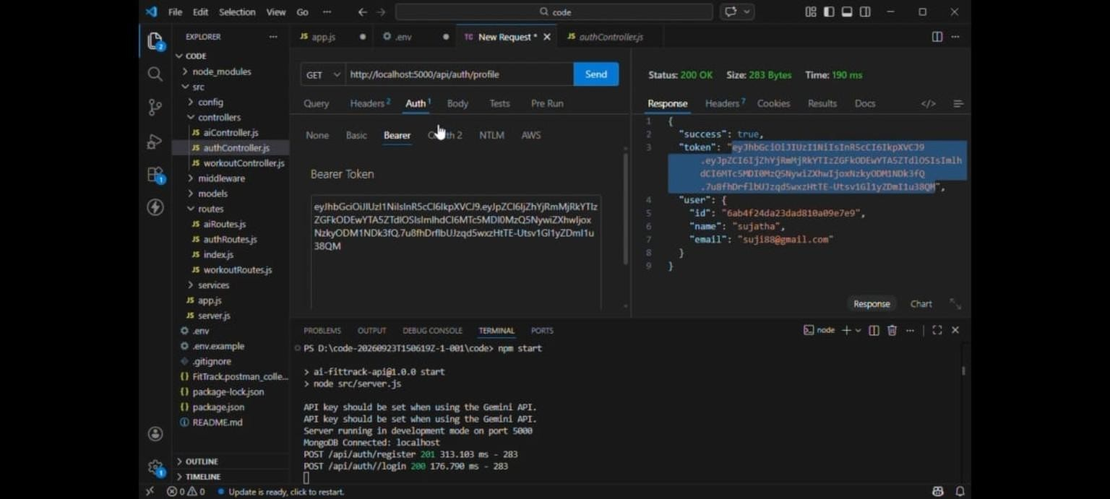
AI FitTrack API | 17/18

Project Summary
AI FitTrack API is a Node.js and Express-based REST backend supported by MongoDB and an AI service. The documentation covers the project background, existing and proposed systems, objectives, requirements, architecture, API implementation, modules, database design, testing, results, advantages, limitations and conclusion. The supplied API test results demonstrate successful registration, authentication, protected profile access, workout recommendation and fitness-insight operations. The project can be extended into a complete fitness platform by adding a

front-end application, richer workout history, analytics, validation and production deployment features.

Conclusion
AI FitTrack API | 18/18

AI FitTrack API successfully demonstrates a backend architecture for a fitness application that combines secure authentication, database connectivity and AI-assisted functionality. The implemented REST

endpoints support user registration, login, profile access, workout recommendations and fitness insights. Testing through Thunder Client confirms successful communication between the client, server, database and AI service. The modular design provides a strong foundation for integrating the API with a mobile or web interface and for adding more personalized fitness features in future development.

AI FitTrack API | 16/18

